TASK 1:
//22k-4080
#include <iostream>
using namespace std;

class Node{
public:
Node* next;
int data;

Node(){
next=NULL;
data=0;
}

Node(int d){
next = NULL;
data = d;
}
};

class CircularLinkedList{
public:
Node* head;
Node* Tail;

CircularLinkedList(int d){
head = new Node(d);
Tail = head;
}

void printList(){
Node* print = head;
while(print!=NULL){
cout<<print->data<<"->";
if(print->next==head){
break;
}
else{
print = print->next;
}
}
cout<<"NULL";
}

void insertAtEnd(int d){
Node* newEnd = new Node(d);
newEnd->next = head;
Tail->next = newEnd;
Tail = newEnd;
}

void insertAtFirst(int d){
Node* newHead= new Node(d);
Tail->next = newHead;
newHead->next = head;
head = newHead;
}

void insertNodeAfter(int val, int position) {
Node* newNode = new Node(val);

if (position == 1) {
if (head == NULL) {
newNode->next = newNode;
head = newNode;
} else {
Node* temp = head;
while (temp->next != head) {
temp = temp->next;
}
temp->next = newNode;
newNode->next = head;
head = newNode;
}
} else {
Node* temp = head;
for (int i = 1; i < position - 1; i++) {
if (temp == NULL || temp->next == head) {
cout << "Invalid position. Position exceeds list length." << endl;
return;
}
temp = temp->next;
}

newNode->next = temp->next;
temp->next = newNode;
}
}

void deleteNode(int position) {
if (head == nullptr) {
cout << "List is empty. Nothing to delete." << endl;
return;
}

if (position == 1) {
if (head->next == head) {
delete head;
head = nullptr;
} else {
Node* temp = head;
while (temp->next != head) {
temp = temp->next;
}
temp->next = head->next;
Node* temp2 = head;
head = head->next;
delete temp2;
}
} else {
Node* temp = head;
Node* prev = nullptr;
int count = 1;

while (count < position) {
prev = temp;
temp = temp->next;
count++;
if (temp == head) {
cout << "Invalid position. Position exceeds list length." << endl;
return;
}
}

prev->next = temp->next;
delete temp;
}
}

};

int main(){
CircularLinkedList l1(67);
l1.insertAtEnd(55);
l1.insertAtEnd(56);
l1.insertAtFirst(402);
l1.insertNodeAfter(221,2);
l1.printList();
cout<<"\nNode After Deletion:"<<endl;
l1.deleteNode(3);
l1.printList();

return 0;

}
OUTPUT:
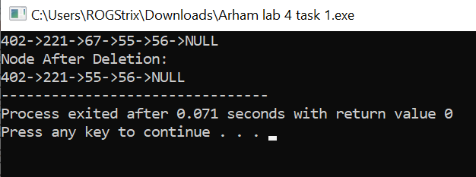
TASK 2:
#include <iostream>
using namespace std;
struct Node {
int key;
Node* next;
Node(int k){
key = k;
next = nullptr;
}
};

void insertAtEnd(Node*& head, int key) {
Node* newNode = new Node(key);
if (head == nullptr) {
head = newNode;
} else {
Node* current = head;
while (current->next != nullptr) {
current = current->next;
}
current->next = newNode;
}
}

Node* reverseList(Node* head) {
Node* prev = nullptr;
Node* current = head;
while (current != nullptr) {
Node* next = current->next;
current->next = prev;
prev = current;
current = next;
}
return prev;
}

void extractReverseAppend(Node*& head) {
if (head == nullptr || head->next == nullptr) {
return;
}

Node* originalList = head;
Node* extractedList = nullptr;

Node* current = head;
Node* prev = nullptr;
while (current != nullptr) {
if (current->next != nullptr) {

Node* extractedNode = current->next;
current->next = current->next->next;

extractedNode->next = nullptr;
if (extractedList == nullptr) {
extractedList = extractedNode;
} else {
Node* temp = extractedList;
while (temp->next != nullptr) {
temp = temp->next;
}
temp->next = extractedNode;
}
}
prev = current;
current = current->next;
}

extractedList = reverseList(extractedList);

if (prev != nullptr) {
prev->next = extractedList;
} else {
head = extractedList;
}
}

void printList(Node* head) {
Node* current = head;
while (current != nullptr) {
cout << current->key << "->";
current = current->next;
}
cout <<"NULL"<<endl;
}

int main() {
Node* head = nullptr;
insertAtEnd(head, 10);
insertAtEnd(head, 4);
insertAtEnd(head, 9);
insertAtEnd(head, 1);
insertAtEnd(head, 3);
insertAtEnd(head, 5);
insertAtEnd(head, 9);
insertAtEnd(head, 4);

cout << "Original Linked List: ";
printList(head);

extractReverseAppend(head);

cout << "Modified Linked List: ";
printList(head);

return 0;
}
OUTPUT:
